[E102] Boil pump

Remove the heat insulations.

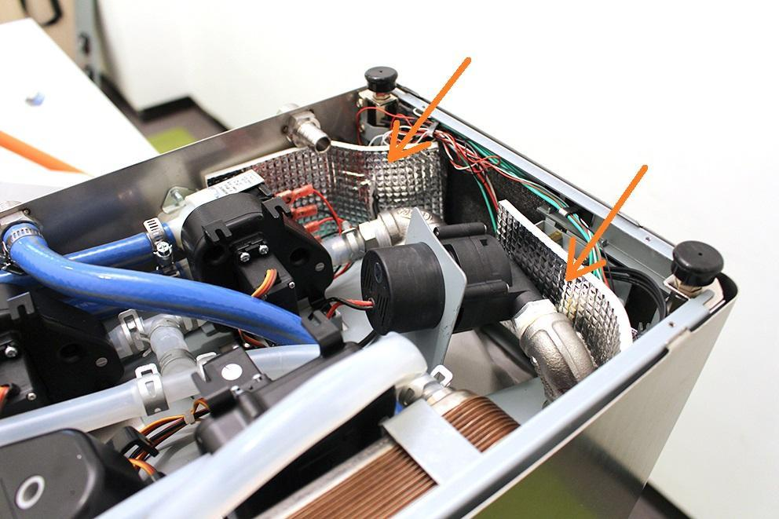

Pull off the pipe clamp from the encircled fitting and bend back the silicone pipe from the fitting.

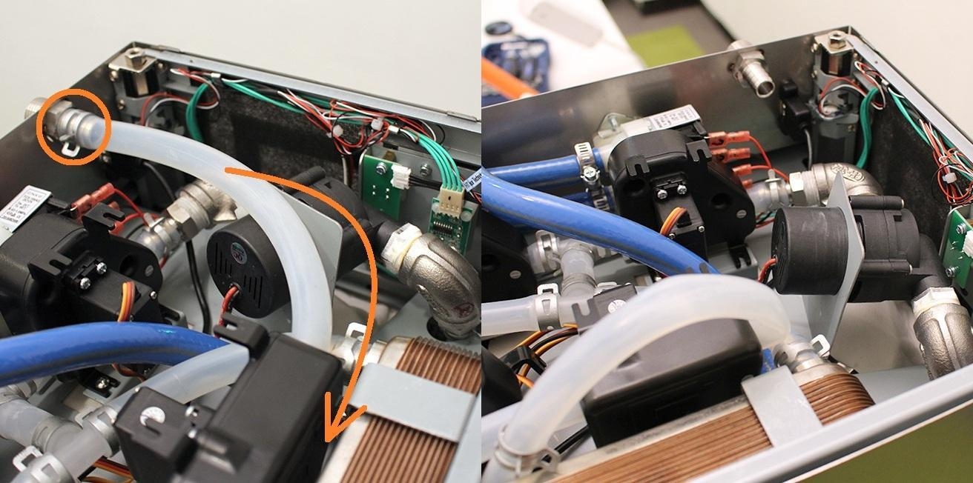

Pull off the pipe clamp from the encircled fitting. Pull off the silicone hose from the fitting.

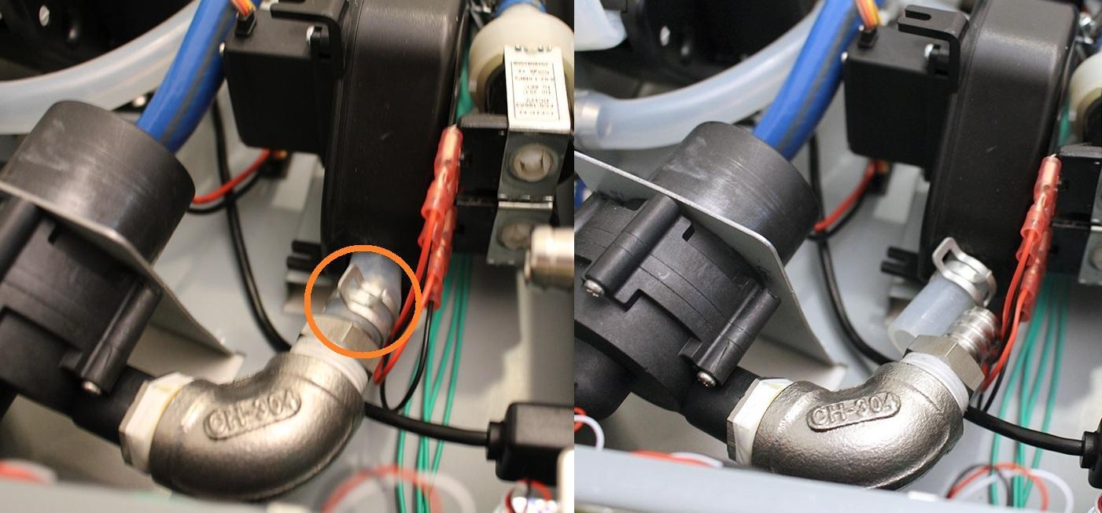

While you keep the indicated pipe clamp tight, you can pull off the pump from the silicone tube by rotating the pump around its axis.

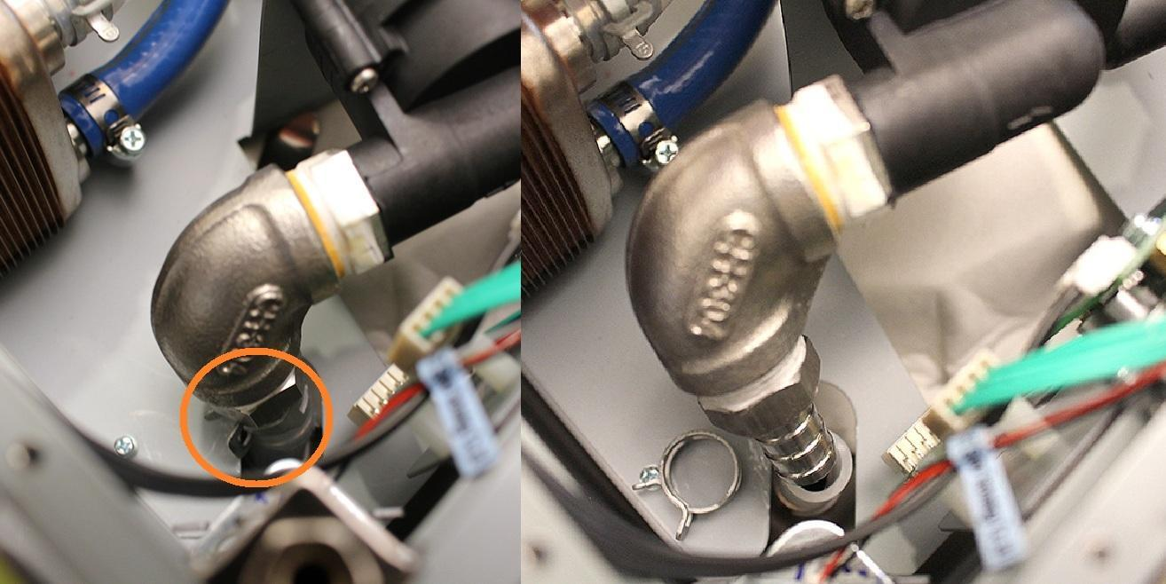

Bend the pump holding sheetmetal carefully backwards in order to remove pump easier.

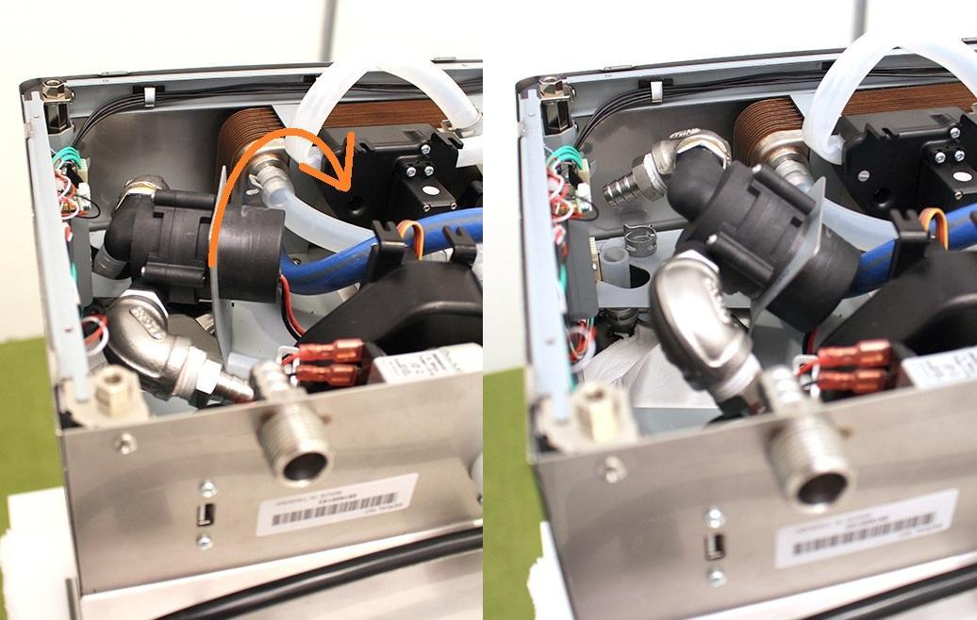

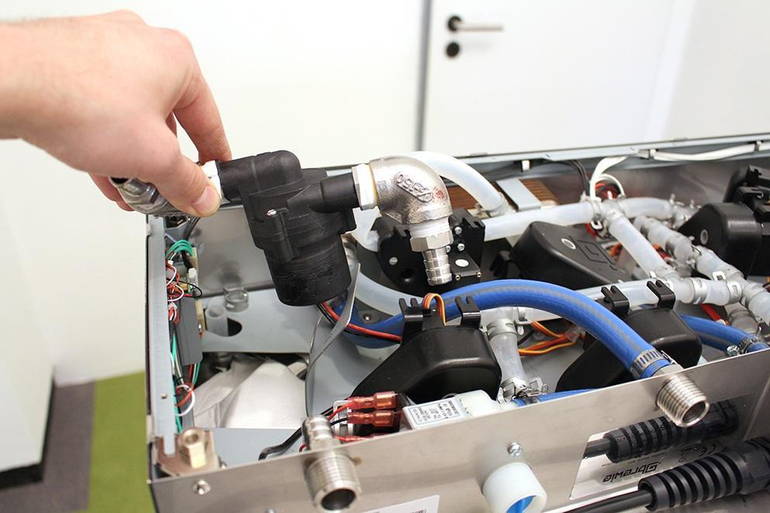

In all case you have to check if the pumps are clogged. If the pump is clogged, you dont have to replace it, you only have to clean it.

You can remove the pump after you disconnected the plug of the pump.

Reassemble consists of the same steps in reverse.

While reassembling, take care that:

1. Make sure that the pump is in the specified angle. Otherwise the pumps will not work properly. Use cable tie to fix the pump.  
     
   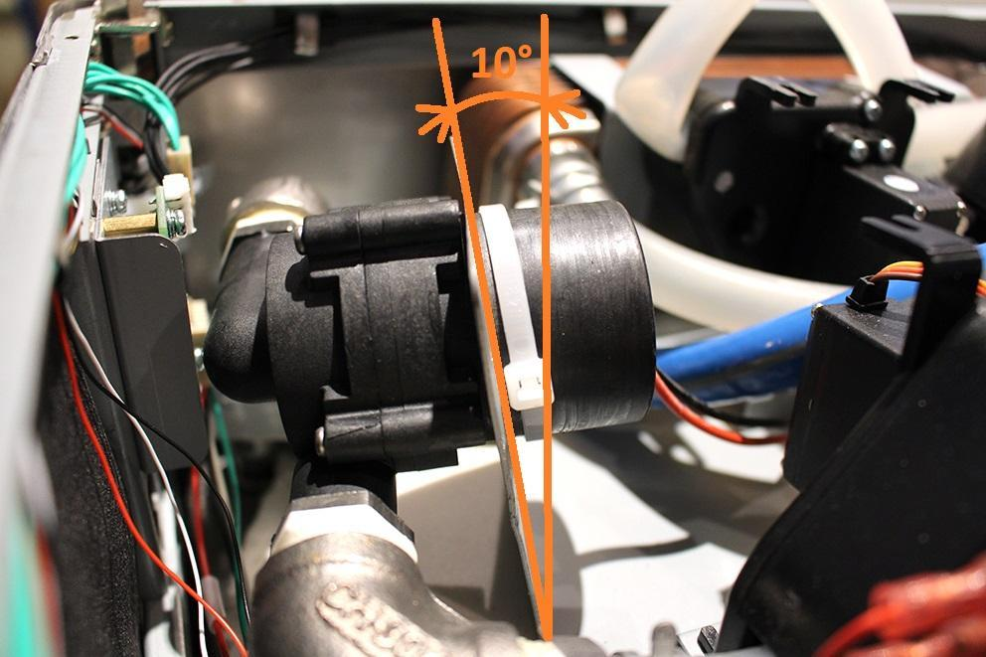

2. Put the heat insulations back to the right positions.



3. Make sure that the wort outlet hose clamp is in the proper angle. Otherwise you cannot reassemble the lower sheetmetal.

